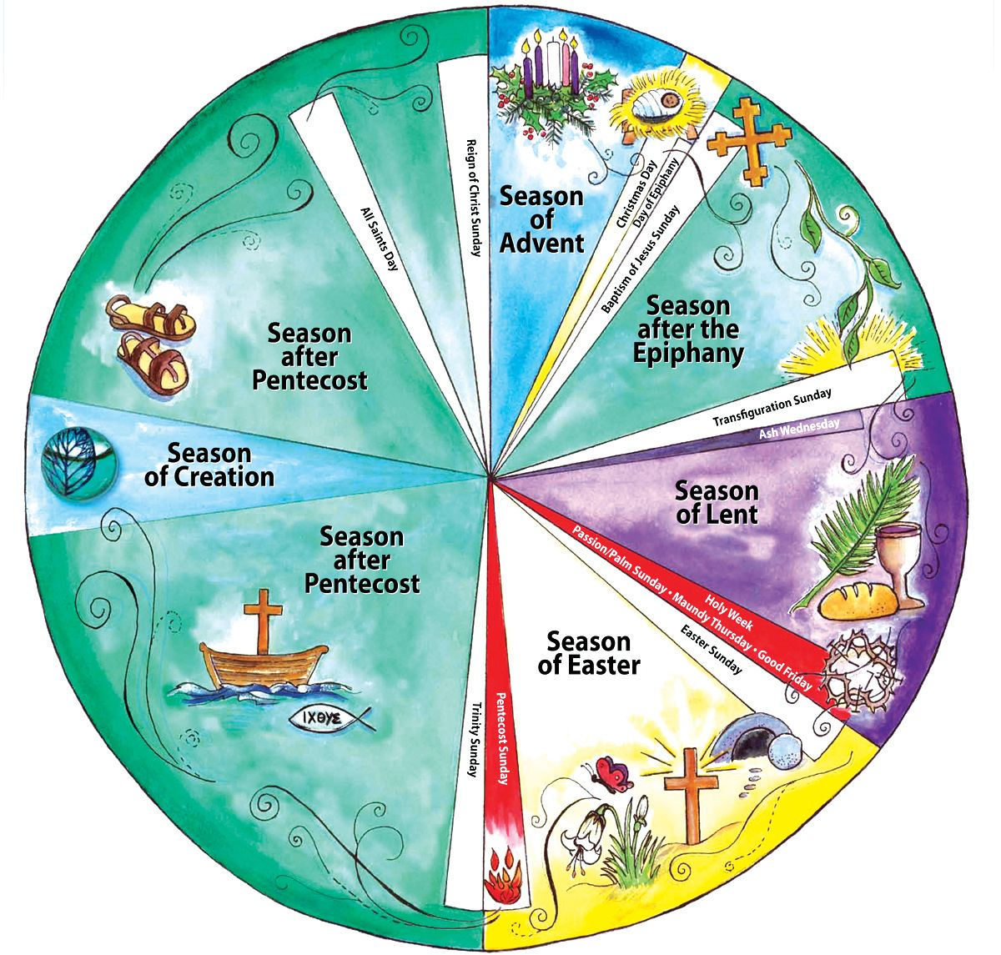

Resources
https://anglican.org.au/our-work/liturgy-worship/holy-communion/
http://anglicanprayerbook.nz/index.html#contents
https://www.churchofengland.org/prayer-and-worship/worship-texts-and-resources/common-worship
Australian Anglicans Remember, Charles Sherlock, Garratt Publishing, 2015
Exciting Holiness (1997) - https://www.excitingholiness.org/first-edition/
Lent, Holy Week and Easter (1986) - http://www.oremus.org/liturgy/lhwe/index.html
The Promise of His Glory (1991) - http://www.oremus.org/liturgy/pohg/

